UNIVERSITY OF IBADAN
DEPARTMENT OF COMPUTER SCIENCE
B.SC. DEGREE EXAMINATIONS (FIRST SEMESTER, 2022/2023)
CSC 551 (Design and Analysis of Algorithms)
Answer Question 1 and any other Two 2 Hours

Question 1:
- The performance of an algorithm and / or program is the amount of computer memory and time needed to run the algorithm or program. There are two measures of performance of algorithms. Discuss in detail the two measures. [7 marks]
- Explain the objectives behind designing algorithms. [3 marks]
- The classification of algorithms plays a crucial role in Computer Science.
Explain any three reasons to support this assertion. [6 marks]
- Divide and Conquer is an algorithmic paradigm in which the problem is solved
using the Divide, Conquer, and Combine strategy.
- Explain the underline terms. [3 marks]
- Describe with simple diagram how Merge Sort follows the Divide and
Conquer paradigm [2 marks]
- The general solution to Merge Sort Time Complexity is T(n) = aT(n/b) + f(n).
Explain what a, b, n and f(n) denote in the equation. [2 marks]
- Give representative values to a, b, n and f(n) in the equation specified in d(iii) [2 marks]
- Use Master method to solve the time complexity for Merge Sort Algorithm [5 marks]

Question 2:
- The dynamic programming algorithm tries to find the shortest way to a solution
when solving a problem. How? [5 marks]
- Give five (5) characteristics of dynamic programing Algorithms. [5 marks]
- The Floyd-Warshall method uses a technique of dynamic programming.
Explain the problem solved by Floyd-Warshall method and how it solves
it through dynamic programming technique [5 marks]

Question 3:
- Greedy algorithm is designed to achieve optimum solution for a given problem.
Explain the general characteristics of a Greedy algorithm. [4 marks]
- Explain the steps involved in Greedy Algorithm [4 marks]
- Given the following graph, apply greedy approach to find the longest route
in the graph and show that Greedy Algorithms are not always optimal in their solutions [7 marks]

Question 4:
- Differentiate between Memoization and Ammotization in Algorithms’ designs [4 marks]
- Why is Memoization often preferred in Dynamic Programming Techniques? [3 marks]
- Depth-first search is an algorithm for traversing or searching tree or graph data structures.
Using the graph below, describe the operational procedure of Depth-first search algorithm.
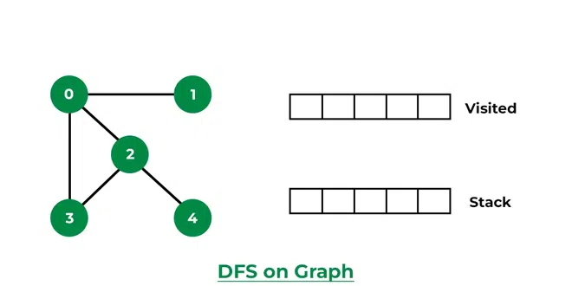 [8 marks]
CSC 551 (Design and Analysis of Algorithms)
2022/2023 Marking Scheme

Question 1:
- The performance of an algorithm and / or program is the amount of computer memory and time needed to run the algorithm or program. There are two measures of performance of algorithms. Discuss in detail the two measures. [7 marks]
- Explain the objectives behind designing algorithms. [3 marks]
- The classification of algorithms plays a crucial role in Computer Science. Explain any three reasons to support this assertion. [6 marks]
- Divide and Conquer is an algorithmic paradigm in which the problem is solved using the Divide, Conquer, and Combine strategy.
- Explain the underline terms. [3 marks]
- Describe with simple diagram how Merge Sort follows the Divide and Conquer paradigm [2 marks]
- The general solution to Merge Sort Time Complexity is T(n) = aT(n/b) + f(n). Explain what a, b, n and f(n) denote in the equation. [2 marks]
- Give representative values to a, b, n and f(n) in the equation specified in d(iii) [2 marks]
- Use Master method to solve the time complexity for Merge Sort Algorithm [5 marks]

Solution:
(a) Discussing the two measures of performance of algorithms

- Time Complexity
The time needed by an algorithm expressed as a function of the size of a problem is called the time complexity of the algorithm. The time complexity of an algorithm is the amount of computer time it needs to run to completion. The limiting behaviour of the complexity as size increases is called the asymptotic time complexity. It is the asymptotic complexity of an algorithm which ultimately determines the size of problems that can be solved by the algorithm. [3 marks]

- Space Complexity

The space complexity of an algorithm and / or a program is the amount of memory it needs to run to completion. [1 mark]
The space need by a program has the following components:
(1) Instruction space: Instruction space is the space needed to store the compiled version of the program instructions.
- The compiler used to compile the program into machine code.
- The target computer. [1 mark]

(2) Data space: Data space is the space needed to store all constant and variable values. Data space has two components:
- Space needed by constants and simple variables in program.
- Space needed by dynamically allocated objects such as arrays and class instances. [1 mark]

(3) Environment stack space: The environment stack is used to save information needed to resume execution of partially completed functions. [1 mark]

(b) The three basic design goals or objectives that one should strive for in an algorithm are:
- Trying to save Time: A program that runs faster is a better program, so saving time is an obvious goal.
- Trying to save Space: A program that saves space over a competing program is considered desirable.
- Trying to save Face: By preventing the program from locking up or generating reams of garbled (distorted or muddled) data. [3 marks]

(c) The classification of algorithms is important for several reasons:
- Organization: Algorithms can be very complex and by classifying them, it becomes easier to organize, understand, and compare different algorithms.
- Problem Solving: Different problems require different algorithms, and by having a classification, it can help identify the best algorithm for a particular problem.
- Performance Comparison: By classifying algorithms, it is possible to compare their performance in terms of time and space complexity, making it easier to choose the best algorithm for a particular use case.
- Reusability: By classifying algorithms, it becomes easier to re-use existing algorithms for similar problems, thereby reducing development time and improving efficiency.
- Research: Classifying algorithms is essential for research and development in computer science, as it helps to identify new algorithms and improve existing ones.
[6 marks for any 3 points discussed]

(d) (i) Divide: This involves dividing the problem into smaller sub-problems. [1 mark]
Conquer: Solve sub-problems by calling recursively until solved. [1 mark]
Combine: Combine the sub-problems to get the final solution of the whole problem. [1 mark]

- Describe with simple diagram how Merge Sort follows the Divide and Conquer paradigm:

Merge sort is a recursive algorithm that continuously splits the array in half until it cannot be further divided i.e., the array has only one element left (an array with one element is always sorted). Then the sorted subarrays are merged into one sorted array.
Illustration with diagrams [2 marks]

- The general solution to Merge Sort Time Complexity is T(n) = aT(n/b) + f(n). Explain what a, b, n and f(n) denote in the equation.

a is the number of sub-problems after division [½ mark]
b is the proportion of the subproblem to the main problem [½ mark]
n is the problem size [½ mark]
f(n) is a function representing the times for Division (D(n)) and Combine (C(n)) [½ mark]

- Give representative values to a, b and f(n) in the equation specified in d(iii) for Merge Sort

a = 2 [½ mark]
b = 2 [½ mark]
f(n) = O(n) [1 mark]

- Use Master method to solve the time complexity for Merge Sort Algorithm

(𝑛) = 2(n / 2) + n
𝑎 = 2, 𝑏 = 2, 𝑓 (𝑛) = 𝑛
Find: log_{𝑏} 𝑎 = log₂ 2 = 1
Because: 𝑐 = log_{𝑏}𝑎 It is case 2 of Master Theorem
𝑇 (𝑛) = (𝑛 ^{log𝑏 𝑎 𝑙𝑜𝑔𝐾+1} 𝑛)
𝑇 (𝑛) = 𝜃 (𝑛¹ ^{𝑙𝑜𝑔0+1} 𝑛) = 𝜃 (𝑛 𝑙𝑜𝑔 n) [5 marks]

Question 2:
- The dynamic programming algorithm tries to find the shortest way to a solution when solving a problem. How? [5 marks]
- Give five (5) characteristics of dynamic programing Algorithms. [5 marks]
- The Floyd-Warshall method uses a technique of dynamic programming. Explain the problem solved by Floyd-Warshall method and how it solves it through dynamic programming technique. [5 marks]

Solution:
2 (a) The dynamic programming algorithm tries to find the shortest way to a solution when solving a problem. It does this by going from the top down or the bottom up. The top-down method solves equations by breaking them into smaller ones and reusing the answers when needed. The bottom-up approach solves equations by breaking them up into smaller ones, then tries to solve the equation with the smallest mathematical value, and then works its way up to the equation with the biggest value. [5 marks]

(b) Characteristics of dynamic programming algorithms
- In general, dynamic programming (DP) is one of the most powerful techniques for solving a certain class of problems.
- There is an elegant way to formulate the approach and a very simple thinking process, and the coding part is very easy.
- Essentially, it is a simple idea, after solving a problem with a given input, save the result as a reference for future use, so you won’t have to re-solve it. Briefly ‘Remember your Past’ :).
- It is a big hint for DP if the given problem can be broken up into smaller sub-problems, and these smaller subproblems can be divided into still smaller ones, and in this process, you see some overlapping subproblems.
- Additionally, the optimal solutions to the subproblems contribute to the optimal solution of the given problem (referred to as the Optimal Substructure Property).
- The solutions to the subproblems are stored in a table or array (memoization) or in a bottom-up manner (tabulation) to avoid redundant computation.
- The solution to the problem can be constructed from the solutions to the subproblems.
- Dynamic programming can be implemented using a recursive algorithm, where the solutions to subproblems are found recursively, or using an iterative algorithm, where the solutions are found by working through the subproblems in a specific order.
[5 marks for any 5 points]
(c) Floyd-Warshall algorithm
The Floyd-Warshall method uses a technique of dynamic programming to locate the shortest pathways. It determines the shortest route across all pairings of vertices in a graph with weights. Both directed and undirected weighted graphs can use it. This program compares each pair of vertices’ potential routes through the graph. It gradually optimizes an estimate of the shortest route between two vertices to determine the shortest distance between two vertices in a chart. With simple modifications to it, one can reconstruct the paths. [5 marks]

Question 3:
- Greedy algorithm is designed to achieve optimum solution for a given problem. Explain the general characteristics of a Greedy algorithm. [4 marks]
- Explain the steps involved in Greedy Algorithm [4 marks]
- Given the following graph, apply greedy approach to find the longest route in the graph and show that Greedy Algorithms are not always optimal in their solutions [7 marks]

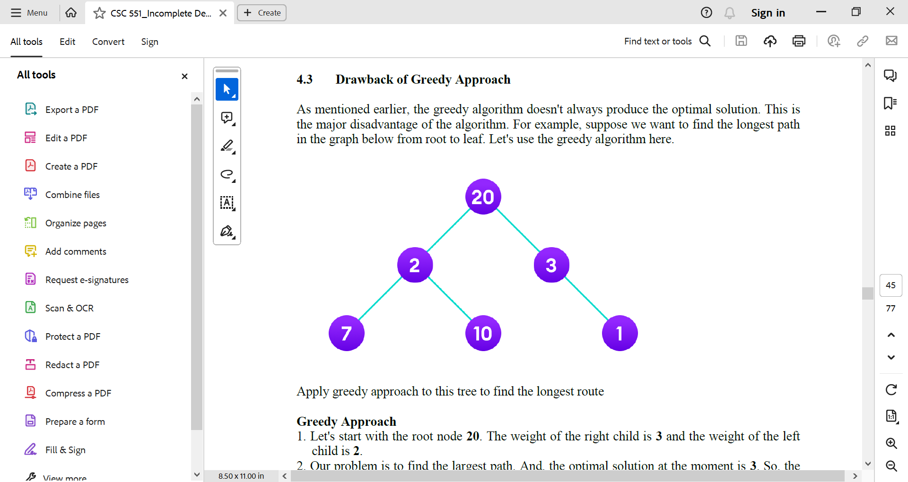

Solution:
- A greedy algorithm is an approach for solving a problem by selecting the best option available at the moment. It doesn't worry whether the current best result will bring the overall optimal result. The algorithm never reverses the earlier decision even if the choice is wrong. It works in a top-down approach. This algorithm may not produce the best result for all the problems. It's because it always goes for the local best choice to produce the global best result. [4 marks]

(b) Steps involved in Greedy Algorithms
- To begin with, the solution set (containing answers) is empty.
- At each step, an item is added to the solution set until a solution is reached.
- If the solution set is feasible, the current item is kept.
- Else, the item is rejected and never considered again. [4 marks]

(c) To apply greedy approach to find the longest route in the graph given
1. Let's start with the root node 20. The weight of the right child is 3 and the weight of the left child is 2.
2. Our problem is to find the largest path. And, the optimal solution at the moment is 3. So, the greedy algorithm will choose 3.
3. Finally the weight of an only child of 3 is 1. This gives us our final result 20 + 3 + 1 = 24.
However, it is not the optimal solution. There is another path that carries more weight (20 + 2 + 10 = 32) as shown in the image below.
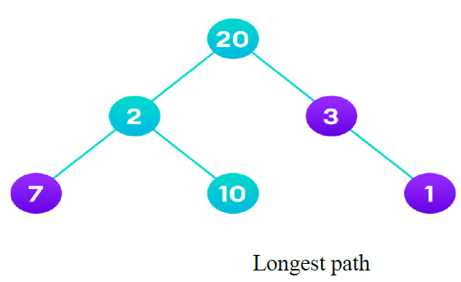
Therefore, greedy algorithms do not always give an optimal/feasible solution. [7 marks]

Question 4:
- Differentiate between Memoization and Ammotization in Algorithms’ designs [4 marks]
- Why is Memoization often preferred in Dynamic Programming Techniques? [3 marks]
- Depth-first search is an algorithm for traversing or searching tree or graph data structures.
Using the graph below, describe the operational procedure of Depth-first search algorithm.

[8 marks]

Solution
- The term “Memoization” comes from the Latin word “memorandum” (to remember), which is commonly shortened to “memo” in American English, and which means “to transform the results of a function into something to remember.” In computing, memoization is used to speed up computer programs by eliminating the repetitive computation of results, and by avoiding repeated calls to functions that process the same input. [2 marks]

Amortization analysis is a technique used in computer science to analyze the average-case time complexity of algorithms that perform a sequence of operations, where some operations may be more expensive than others. The idea is to spread the cost of these expensive operations over multiple operations, so that the average cost of each operation is constant or less. [2 marks]

(b) Memoization is a specific form of caching that is used in dynamic programming. The purpose of caching is to improve the performance of our programs and keep data accessible that can be used later. It basically stores the previously calculated result of the subproblem and uses the stored result for the same subproblem. This removes the extra effort to calculate again and again for the same problem. And we already know that if the same problem occurs again and again, then that problem is recursive in nature. [3 marks]

(c) The Depth-first search algorithm starts at the root node (selecting some arbitrary node as the root node in the case of a graph) and explores as far as possible along each branch before backtracking. Let us understand the working of Depth First Search with the help of the following illustration:

Step1: Initially stack and visited arrays are empty.
Stack and visited arrays are empty initially.

Step 2: Visit 0 and put its adjacent nodes which are not visited yet into the stack.

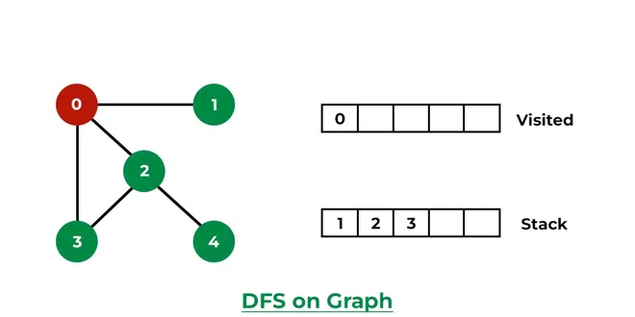
Visit node 0 and put its adjacent nodes (1, 2, 3) into the stack

Step 3: Now, Node 1 at the top of the stack, so visit node 1 and pop it from the stack and put all of its adjacent nodes which are not visited in the stack.

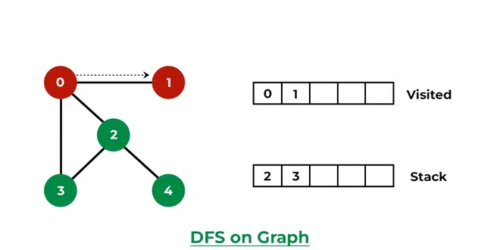
Visit node 1

Step 4: Now, Node 2 at the top of the stack, so visit node 2 and pop it from the stack and put all of its adjacent nodes which are not visited (i.e, 3, 4) in the stack.
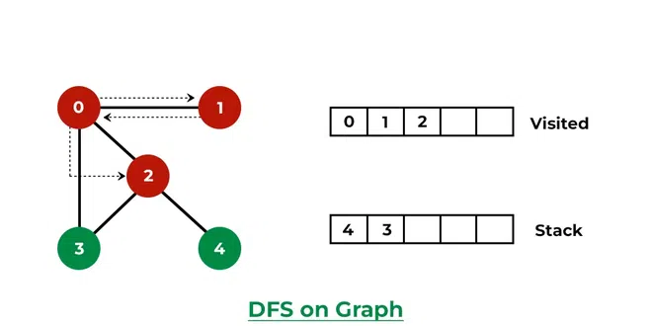

Visit node 2 and put its unvisited adjacent nodes (3, 4) into the stack
Step 5: Now, Node 4 at the top of the stack, so visit node 4 and pop it from the stack and put all of its adjacent nodes which are not visited in the stack.

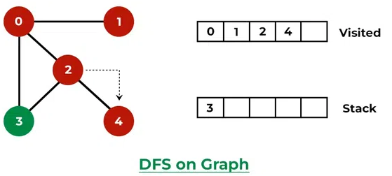

Visit node 4
Step 6: Now, Node 3 at the top of the stack, so visit node 3 and pop it from the stack and put all of its adjacent nodes which are not visited in the stack.

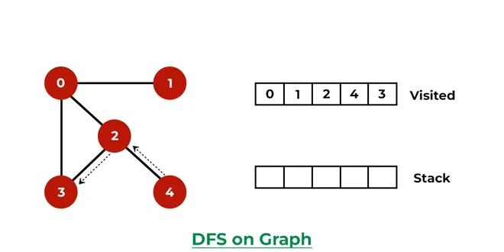

Visit node 3
Now, Stack becomes empty, which means we have visited all the nodes and our DFS traversal ends. [8 marks]

